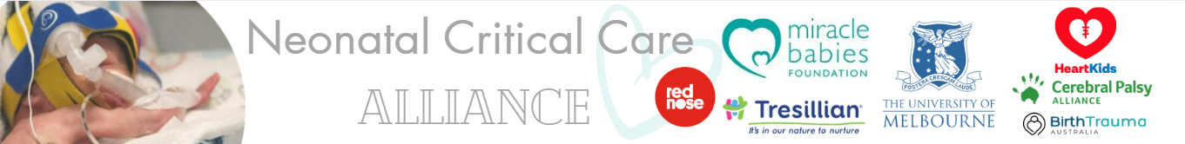
The Hon. XXXXXX MP
Member for XXXXXX

Dear The Hon. XXXXX MP,
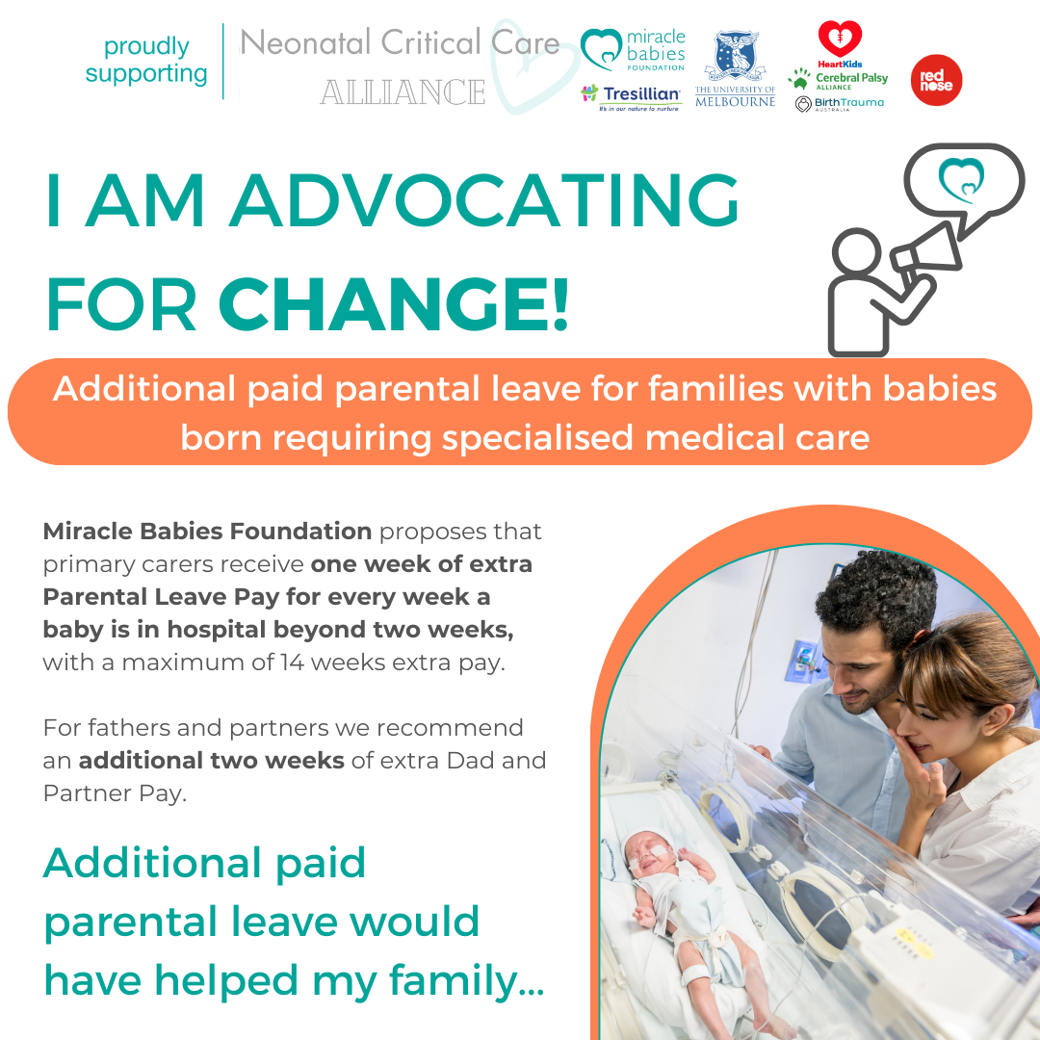
I write to you to show my support for Miracle Babies Foundation in their campaign and call to the Australian Government for an additional paid parental leave payment (Critical Care Leave Payment) for families with a premature or sick newborn in neonatal care over 2 weeks. I support the call from the Neonatal Critical Alliance, made up of Miracle Babies Foundation, Tresillian, University of Melbourne, Birth Trauma Australia, Heart Kids, Cerebral Palsy Alliance and Red Nose.
These babies may spend anywhere from 2 weeks to 4 months or more in NICU or SCN before they are able to safely come home, effectively resulting in parents financially impacted by needing to stop working earlier than planned. Missing out on income during the birth of a premature baby and less time available at home following discharge places tremendous financial strain on families, and many mothers at risk of leaving the workforce much earlier than anticipated to care for their premature or sick baby.
We know that parents of extreme premature babies are 2.5 times more likely to suffer postnatal depression, together with increased risk of PTSD, anxiety and depression. Additional paid parental leave will give more time for parents to adjust to parenting a premature or sick baby with more hospital appointments and ongoing development concerns and challenges and better care for their mental health.
Also, these parents may be forced to put their vulnerable child, who may have low immunity due to their prematurity or sickness at birth, into care earlier than necessary, placing them at risk of contracting serious illness and potentially rehospitalisation.
My child was born at XXXXX weeks and spent XXXX days in hospital, during our stay in the hospital the lack of additional support, having no additional Paid Parental Leave, meant XXXXXXX. It impacted us XXXXXX and also our child who faced XXXXXX.
There is no way that I could have returned to work while my baby was in hospital and not having the same amount of time at home with my baby as other parents (after already missing out on so much) was heartbreaking.
An improved legislation to support these families with an additional special leave entitlement for the hospital period will help to reduce separation and also assist with more women returning to the workforce when they are ready.
As noted in The Early Years strategy launched on 7 May 2024, ‘No child should be left behind’.
With the well evidenced risk factors for babies born early or sick and their parents, the circumstance of their birth is already placing them behind their peers and no additional paid parental leave for the hospital stay is leaving these vulnerable children and families behind.

From our family to the Australian Government, please prioritise this call for Additional Paid Parental Leave and we can help improve Australia’s future generations to thrive. Thank you for your consideration and appreciate your attention to the need for this support.
With regards,
Signed
(Name) XXXXXXXXX

